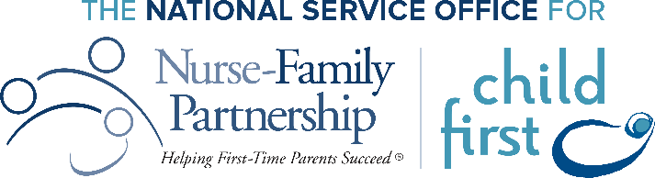

Agency Name

Community Advisory Board Meeting

Date | Time

Location

Welcome

Introductions & Agency Updates

* Choose a topic that everyone can share about.
  + Services after COVID-19: what’s new, what has changed for you, what should we know?

Nurse-Family Partnership Update

* + NFP in a Telehealth World
  + Referral updates and information sharing
  + Themes we are seeing among clients: homelessness, transportation, diaper needs, etc.
  + NFP CAB member resource list from last meeting

Guest Speaker

* NFP Client/Alumni
* Community Partner
* National Service Office

Community Spotlight

* + What organization can you highlight?

Nurse-Family Partnership Needs

* CAB members can provide updates on the NFP team on tasks that they are in the process of supporting the team.
* NFP team discuss how the CAB can support their efforts

Discuss Action Items and Next Meeting:

* Clear action steps for CAB members
* Provide date of next meeting