Nurse-Family Partnership
Generating Referrals

A robust referral network is key to the success of your agency. In addition to having enough referrals to build caseloads, you will need referrals to replace clients as they leave the program. In addition to graduation out of the program, clients will leave early for several reasons, including moving out of the service area, going back to work or school, or no longer wishing to participate in the program. To reach a caseload of 25 or more per nurse in 9 months, your agency will need at least 9 qualified referrals per nurse per month. This number assumes that about 50% of those referred to Nurse-Family Partnership will enroll. If you have a higher enrollment rate, you may need fewer referrals, and if you have a lower enrollment rate, you will need more referrals.

Because Nurse-Family Partnership is voluntary, not every referral will choose to enroll in your program. Use this worksheet to explore the relationships and processes your agency will put in place to ensure a steady flow of qualified referrals. This worksheet will also help you explore how you will provide your staff with strong orientation and education to support outreach activities, and the enrollment and retention of the referrals that your agency receives.

Building Referral Partnerships

Connecting your program to community partners is essential to building a strong referral network. This strong referral network will enable you to maintain a pipeline of new and interested clients ensuring that every eligible and interested family in your community is served by Nurse-Family Partnership. This will help your nurse home visitors to maintain their caseloads consistently and to effectively partner with the families they serve. Start thinking through and mapping out your community partnerships by filling out the chart below:

Partner Name | NFP Champion | Estimated time from identifying referral to sending to you
Click or tap here to enter text. | Click or tap here to enter text. | Click or tap here to enter text.
Click or tap here to enter text. | Click or tap here to enter text. | Click or tap here to enter text.
Click or tap here to enter text. | Click or tap here to enter text. | Click or tap here to enter text.
Click or tap here to enter text. | Click or tap here to enter text. | Click or tap here to enter text.

What processes and workflows will you put in place? Will you have a feedback loop?
Click or tap here to enter text.

Strong referral partnerships are mutually beneficial. Think about how to work together to reach shared goals.

How will you ensure ongoing collaboration and coordination with the partners listed above?
Click or tap here to enter text.

A strong referral process, in collaboration with other service providers, ensures that mothers receive the services that best meet their needs.

Developing a Strong System of Process
An essential part of developing strong community partnerships is developing clear processes for sending, receiving, and acting on referrals. If your process isn’t strong, it’s very likely that referrals will begin to fall through the cracks -- a frustrating situation for your referral partners that will also leave eligible and interested families unserved. Consider the following questions:

What conversations are you currently having with potential referral sources about referral processes?
Click or tap here to enter text.

How do you plan to develop and maintain a referral network?
Click or tap here to enter text.

What is the anticipated amount of time between when your agency receives the referral and reaching out to the referral?
Click or tap here to enter text.

If actual referrals are insufficient, what is your plan for addressing this challenge?
Click or tap here to enter text.

Describe how referrals that do not qualify for Nurse-Family Partnership will be managed.
Click or tap here to enter text.

Nurse-Family Partnership shows the greatest impact with mothers at the highest risk.

Partnership champions.

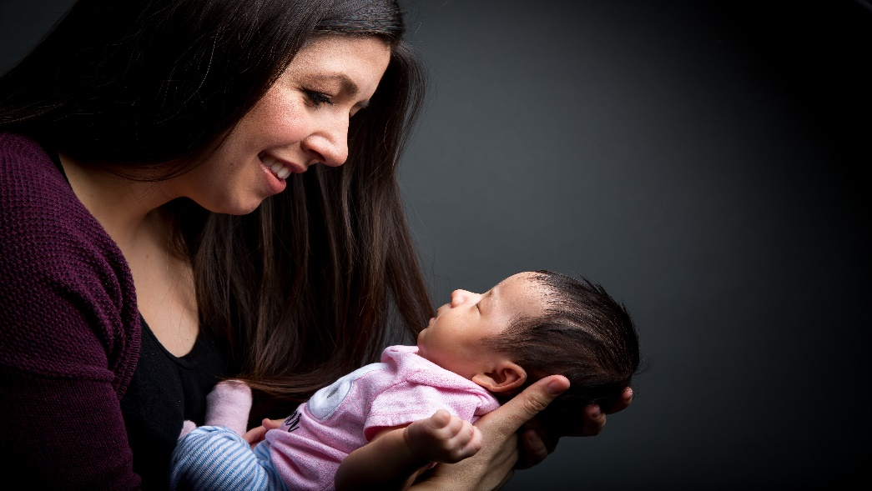

Things to consider:

- How comfortable are you/they in making cold calls to clients or recruiting in person?

- How comfortable are you/they with speaking to agencies and audiences?

- Will you make the initial introduction and gain a written agreement (which is sometimes necessary for clinics and the like) or a representative of your agency?

- Is the Administrative Assistant going to input referrals and disposition into the Data Collection System or will the NHV have access to do so if necessary?

Marketing and Outreach

Not all referrals will come through referral partners. In fact, it can be extremely effective to do marketing and outreach that encourages mothers to self-refer to your Nurse-Family Partnership program.

What marketing and outreach efforts, if any, has your agency undertaken in the past?
Click or tap here to enter text.

In what ways was that marketing effort successful? In what ways was it not?
Click or tap here to enter text.

Who at your agency will take primary responsibility for marketing and outreach?
Click or tap here to enter text.

How will you orient those staff and provide support?
Click or tap here to enter text.

Are there funding resources that you can draw on to support marketing and outreach efforts?
Click or tap here to enter text.

A Guide to Referrals
A qualified referral is:
Pregnant
A 1st time mother
Before the end of 28 weeks
A voluntary participant

Building up your referral pipeline won’t happen overnight, but you should be able to map out steady progress towards your goal. You should endeavor to have nurses reach full caseload within nine months of returning from Unit 2 education. This timeframe allows
for nurses to steadily build caseloads, while granting time for ongoing education and orientation to your agency and the NFP model.

When mapping out your referral plan, be sure to account for referrals choosing not to enroll in the program, as well as clients graduating or leaving the program early. Start collecting referrals in the weeks leading up to nurses attending Unit 2 so they have clients to enroll and begin visiting once they return from education.

Use the table below to map out the minimum number of qualified referrals your agency will need each month. Additional rows are provided to account for staggered hiring. Plan on a minimum of 9 referrals per month per nurse for nurses building caseload. Once nurses have reached full caseload, they will need 2-3 referrals per month to maintain caseload, depending on your agency enrollment rate.

Month | # of Referrals |  | # of Nurses |  | Minimum # of referrals needed per month
1 | 9 | x | Click or tap here to enter text. | = | Click or tap here to enter text.
2 | 9 | x | Click or tap here to enter text. | = | Click or tap here to enter text.
3 | 9 | x | Click or tap here to enter text. | = | Click or tap here to enter text.
4 | 9 | x | Click or tap here to enter text. | = | Click or tap here to enter text.
5 | 9 | x | Click or tap here to enter text. | = | Click or tap here to enter text.
6 | 9 | x | Click or tap here to enter text. | = | Click or tap here to enter text.
7 | 9 | x | Click or tap here to enter text. | = | Click or tap here to enter text.
8 | 9 | x | Click or tap here to enter text. | = | Click or tap here to enter text.
9 | 9 | x | Click or tap here to enter text. | = | Click or tap here to enter text.
 |  |  |  | Total | Click or tap here to enter text.

