Nurse-Family Partnership
Building Champions

Even the strongest, most effective programs cannot survive without political and financial support. That support must come from within your agency and from the outside community. Programs with ample funding from stable, long-term sources will still need to demonstrate their value and make the case for continued support. For many, the need for this advocacy arises sooner than ever imagined.

You need a strong network of individuals and groups that are well-informed about the value of Nurse-Family Partnership® (NFP) and its ongoing contributions to the community. This network must be able and willing to use their influence on behalf of NFP. These champions will help you maintain NFP’s visibility and express gratitude to all of those who support you. They can introduce NFP to new leaders who will have a say over whether, and how much, funding will be available to you in the future. In consultation with your NFP Program Development Specialist, use this worksheet to develop a plan for cultivating and maintaining champions for your NFP program. If a sustainability issue should arise, these will be the champions you will engage to support the continuation of your program.

Internal Champions

Briefly describe how support for implementation of NFP evolved within your agency. Please provide background information that speaks to the commitment of your organization’s leadership to serving the community through NFP implementation.
Click or tap here to enter text.

Which position within your agency will directly oversee the Nurse-Family Partnership (i.e., supervise the NFP Supervisor)?

Name: Click or tap here to enter text.

Title: Click or tap here to enter text.

Who in the agency’s top leadership will be the primary supporter and advocate for the program?

Name: Click or tap here to enter text.

Title: Click or tap here to enter text.

Aspects of an Ideal Champion
- Believes in Nurse-Family Partnership and passionate about the needs of clients
- Is willing to put time and/or money into advocating for NFP
- Respected within their circle of influence
- Has influential relationships with people in positions relevant to NFP
- Can persuasively and accurately articulate what NFP does to others
- Is comfortable acting and speaking in a bipartisan fashion
- Understands the value of sharing successes and building broad ownership of NFP

It is important to cultivate widespread support for NFP within your agency. Doing so ensures that if a program administrator or other champion moves on, there remains a strong network of support for the program.

Besides your primary advocate, who at your agency is a potential champion of NFP? How will you share the program with them and gain their support?

Name/Title | Plan to Engage | Timeline
Click or tap here to enter text. | Click or tap here to enter text. | Click or tap here to enter text.
Click or tap here to enter text. | Click or tap here to enter text. | Click or tap here to enter text.
Click or tap here to enter text. | Click or tap here to enter text. | Click or tap here to enter text.
Click or tap here to enter text. | Click or tap here to enter text. | Click or tap here to enter text.
Click or tap here to enter text. | Click or tap here to enter text. | Click or tap here to enter text.
Click or tap here to enter text. | Click or tap here to enter text. | Click or tap here to enter text.
Click or tap here to enter text. | Click or tap here to enter text. | Click or tap here to enter text.
Click or tap here to enter text. | Click or tap here to enter text. | Click or tap here to enter text.

In the event of budget cuts or hiring freezes, how does your agency prioritize which programs to continue supporting? Does NFP fit within these priorities? How would you make the case for continued support of NFP?
Click or tap here to enter text.

In the event of leadership changes, how will you transfer the commitment of departing leadership to Nurse-Family Partnership? What is your succession plan?
Click or tap here to enter text.

Current Political, Advocacy and Community Champions

What organizations and individuals outside of your agency have been instrumental in bringing NFP to the community (e.g., elected officials, advocacy groups, foundations, health care providers, etc.)? What is your plan to keep them engaged with the NFP program after implementation begins?

Name/Title | Type of Support | Plan to Engage | Timeline | Level of Support  (1 - 5)*
Click or tap here to enter . | Choose an item. | Click or tap here to enter . | Click or tap here to enter . | Click or tap here to enter .
Click or tap here to enter . | Choose an item. | Click or tap here to enter . | Click or tap here to enter . | Click or tap here to enter .
Click or tap here to enter . | Choose an item. | Click or tap here to enter . | Click or tap here to enter . | Click or tap here to enter .
Click or tap here to enter . | Choose an item. | Click or tap here to enter . | Click or tap here to enter . | Click or tap here to enter .
Click or tap here to enter . | Choose an item. | Click or tap here to enter . | Click or tap here to enter . | Click or tap here to enter .
Click or tap here to enter . | Choose an item. | Click or tap here to enter . | Click or tap here to enter . | Click or tap here to enter .
Click or tap here to enter . | Choose an item. | Click or tap here to enter . | Click or tap here to enter . | Click or tap here to enter .
Click or tap here to enter . | Choose an item. | Click or tap here to enter . | Click or tap here to enter . | Click or tap here to enter .
*1 - will attend events, make in-kind donations, etc.
5 - actively engaged in legislative visits, writing op-eds, leveraging their network on behalf of the program

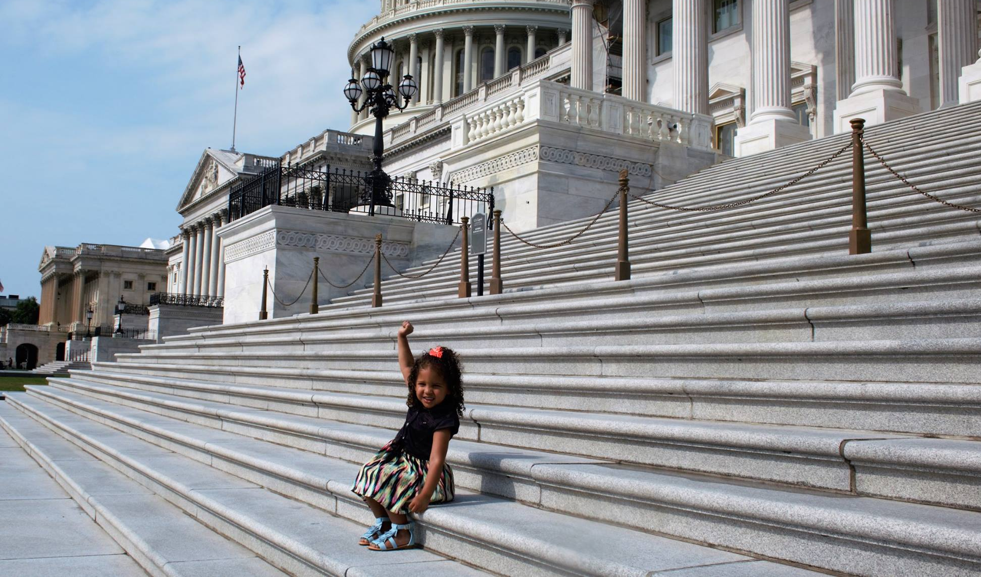
“The program has demonstrated improved prenatal health, reduced childhood injuries and abuse, and lessened mental health problems for children.”
– Fmr. Michigan Governor Rick Snyder

Future Political, Advocacy and Community Champions

Think through examples of a time when you have engaged with external champions. Describe what sort of strategies and tactics you could draw from those experiences to help you build and sustain a strong network of Nurse-Family Partnership champions.
Click or tap here to enter text.

As you begin implementing NFP, it’s important to broaden your network of champions. Who in the community is a potential NFP champion? What is your plan to expose them to NFP and gain their support?

Name/Title | Type of Support | Plan to Engage | Timeline | Expected Level of Support  (1 - 5)*
Click or tap here to enter . | Choose an item. | Click or tap here to enter . | Click or tap here to enter . | Click or tap here to enter .
Click or tap here to enter . | Choose an item. | Click or tap here to enter . | Click or tap here to enter . | Click or tap here to enter .
Click or tap here to enter . | Choose an item. | Click or tap here to enter . | Click or tap here to enter . | Click or tap here to enter .
Click or tap here to enter . | Choose an item. | Click or tap here to enter . | Click or tap here to enter . | Click or tap here to enter .
Click or tap here to enter . | Choose an item. | Click or tap here to enter . | Click or tap here to enter . | Click or tap here to enter .
Click or tap here to enter . | Choose an item. | Click or tap here to enter . | Click or tap here to enter . | Click or tap here to enter .
Click or tap here to enter . | Choose an item. | Click or tap here to enter . | Click or tap here to enter . | Click or tap here to enter .
Click or tap here to enter . | Choose an item. | Click or tap here to enter . | Click or tap here to enter . | Click or tap here to enter .
*1 - will attend events, make in-kind donations, etc.
5 - actively engaged in legislative visits, writing op-eds, leveraging their network on behalf of the program

Will your agency be able to lobby and/or provide advocacy on behalf of Nurse-Family Partnership? yes/no, conditional explanations (direct, grassroots).
Click or tap here to enter text.

Will your agency be able to educate elected officials and staff about Nurse-Family Partnership?
Click or tap here to enter text.

Community Advisory Board
Model Element 18
“A Nurse-Family Partnership implementing agency convenes a long-term Community Advisory Board…to implement a community support system for the program and to promote program quality and sustainability.”

Successful implementation of the NFP model depends on a strong Community Advisory Board (CAB). NFP founder Dr. David Olds recognized that NFP programs cannot survive, thrive or grow without buy-in and support from the local community. For this reason, incorporating a CAB into NFP implementation is one of the 19 Model Elements. A strong, reliable CAB can catalyze other local stakeholders and champions to support your NFP program. By having members promote NFP’s successes, address challenges, develop solutions and raise awareness across a diverse pool of potential supporters, a CAB can prompt the wider community to take action on behalf of NFP.

CAB members should serve specific functions and roles that are intentional in meeting the needs of the agency and the families you serve. The needs of your NFP will change over time; for this reason, membership should be evaluated and refined as the needs of your local NFP program evolve.

During the first year, the CAB typically supports the beginning phase of implementation by bolstering linkages for our families to other needed services and supports, generating strong referral pipelines and/or brainstorming nurse recruitment strategies. Over time, the CAB plays a key role in helping to secure sustainable funding for the agency through advocacy and developing political champions at the local, state and national levels.

Whether you are developing a new Community Advisory Board or strengthening an existing one, the first step is to identify the needs of your program. What have you identified as the current needs, and what are the ways in which your Community Advisory Board can support the NFP team during the first year of implementation?
Click or tap here to enter text.

Describe your plan and timeframe for convening, supporting and communicating with your advisory board members during the first year of program implementation.
Click or tap here to enter text.

Describe how you imagine leveraging your Community Advisory Board to help fill in gaps in resources for your program. (e.g., we will ask CAB members to seek funds for incentives for families)
Click or tap here to enter text.

