Thank you for taking action for MIECHV! Below we have provided everything you need for 3 days of action, with a different action for each day.
If you have questions, people reach out to NFP-NSO Advocacy Coordinator, Katelyn Moga at: Katelyn.moga@nursefamilypartnership.org
DAY 1: Tuesday, October 24- Call Your Members of Congress

You can find your Members of Congress and their phone numbers here: https://callyourrep.co/
When calling your senators:
Hello, my name is _______ and I live in _______. I’m calling to urge Senator _______ to renew federal funding for home visiting by supporting Senate bill 1829, bipartisan legislation that reauthorizes the Maternal, Infant, and Early Childhood Home Visiting program for five years without a harmful state match. It’s been two weeks since inaction allowed the program to expire, and services and jobs are on the line. So, I’m asking Senator _____ do everything in his/her power to pass S. 1829 as soon as possible. The clock is ticking. Children and families across the country are counting on Senator _____ and his/her colleagues to pass federal funding for home visiting. Thank you.
When calling your representative:
Hello, my name is _______ and I live in _______. I’m calling to urge Representative _______ to renew federal funding for home visiting by supporting S. 1829, bipartisan legislation that reauthorizes the Maternal, Infant, and Early Childhood Home Visiting program for five years without a harmful state match. It’s been two weeks since inaction allowed the program to expire, and jobs and services are on the line. So, I’m asking Representative _____ do everything in his/her power to pass this legislation as soon as possible. The clock is ticking. Children and families across the country are counting on Representative _____ and his/her colleagues to pass federal funding for home visiting. Thank you.

DAY 2: Wednesday, October 25 -Tweet at your Senators

You can use these sample tweets or draft your own! Let your Senators know that you are a constituent and add one of the graphics below. Plus, check out these updated graphics from the National Home Visiting Coalition!
You can find your Senators’ Twitter handles here: https://twitter.com/cspan/lists/senators/members
Sample Tweets:
Dear @memberofcongress children & families are counting on you to #renewMIECHV now.
Federal home visiting funding expired 2 weeks ago. @memberofcongress #RenewMIECHV now.
MIECHV is good for families, good for states & good for taxpayers. What are we waiting for? @memberofcongress #RenewMIECHV
Every second Congress waits to #RenewMIECHV is a second closer to lost jobs & lost services. @memberofcongress act now!
The clock is ticking! @memberofcongress Please support bipartisan legislation to #RenewMIECHV now.
Take a look here to see if your senators have already sponsored S. 1829. If they have, consider thanking them with this tweet:
Thank you @memberofcongress for co-sponsoring S. 1829 to #renewMIECHV! Ask your colleagues to join you.
If they haven’t, ask them to do so with this tweet:
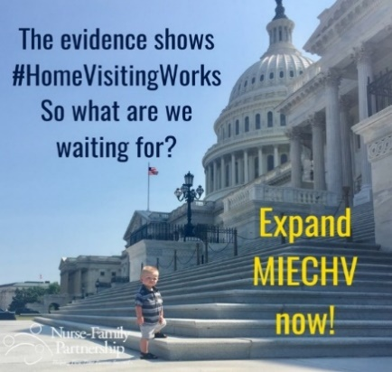
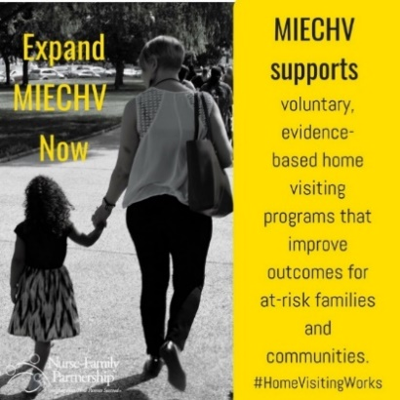
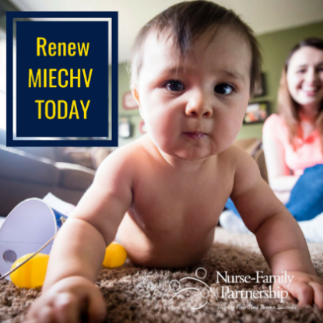
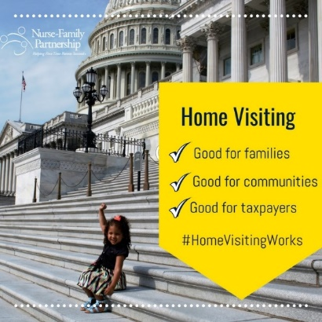
Dear @memberofcongress please co-sponsor S. 1829, bipartisan legislation to #renewMIECHV for 5 years, now.

DAY 3: Thursday, October 26th- Email your Members of Congress

Click here to send a direct message to your Members of Congress: https://www.votervoice.net/NFP/campaigns/54522/respond
You can copy and paste the below sample text into the body of the message. If you are a parent, we encourage you to add details about your personal story and the impact home visiting has had on your family.
When emailing your senators:
Subject line: Support S. 1829 to Renew MIECHV – your constituents are counting on you
Dear Senator ______,
My name is ______ and I live in _______.
I’m writing to urge you to renew federal funding for home visiting by supporting Senate bill 1829, bipartisan legislation that reauthorizes the Maternal, Infant, and Early Childhood Home Visiting program for five years without a harmful state match.
It’s been two weeks since inaction allowed the program to expire, and jobs and services are on the line.
Please do everything in your power to pass this legislation as soon as possible. The clock is ticking. Every second that Congress waits is a second closer to lost services and lost jobs.
Children and families across the country are counting on you and your colleagues to pass federal funding for home visiting.
Thank you.
Sincerely,
NAME
CITY

When emailing your representatives:
Subject line: Support S. 1829 to Renew MIECHV – your constituents are counting on you
Dear Representative ______,
My name is ______ and I live in _______.
I’m writing to urge you to renew federal funding for home visiting by supporting S. 1829, bipartisan legislation that reauthorizes the Maternal, Infant, and Early Childhood Home Visiting program for five years without a harmful state match.
It’s been two weeks since inaction allowed the program to expire, and jobs and services are on the line.
Please do everything in your power to pass this legislation as soon as possible. The clock is ticking. Every second that Congress waits is a second closer to lost services and lost jobs.
Children and families across the country are counting on you and your colleagues to pass federal funding for home visiting.
Thank you.
Sincerely,
NAME
CITY

