Thank you for taking action for MIECHV! Below we have provided everything you need for the upcoming MIECHV Days of Action.
If you have questions, people reach out to NFP-NSO Advocacy Coordinator, Katelyn Gesing at: Katelyn.Gesing@nursefamilypartnership.org
Call Your Members of Congress

You can find your Members of Congress and their phone numbers here: https://callyourrep.co/
When calling your senators/representatives:
Hello. My name is ________ and I'm from __________. I'm calling to ask Sen./Rep. __________ to make sure that the Maternal, Infant, and Early Childhood Home Visiting program is reauthorized NOW. MIECHV must be reauthorized for no less than its current funding level of $400 million annually for five years. Congressional inaction let federal funding for home visiting expire more than 100 days ago. We are hearing that some states may freeze enrollment, putting home visiting services at risk. Words of support for MIECHV are not enough – we need action. Reauthorize federal funding for home visiting now.
Tweet at your Members of Congress

You can use these sample tweets or draft your own! Let your Members of Congress know that you are a constituent and add one of the graphics below.
You can find your Senators’ Twitter handles here: https://twitter.com/cspan/lists/senators/members
You can find your Representatives’ Twitter handles here: https://twitter.com/cspan/lists/u-s-representatives/members
Sample Tweets:
Congress let federal funding for home visiting expire 100+ days ago. Words of support are not enough. We need action. @memberofcongress #RenewMIECHV now.
The clock is ticking. Every second Congress waits is a second closer to lost services and lost jobs. @memberofcongress #RenewMIECHV now.
MIECHV is good for families, good for states & good for taxpayers. What are we waiting for? @memberofcongress #RenewMIECHV
Dear @memberofcongress Welcome back to DC. We’re counting on you to #RenewMIECHV now.
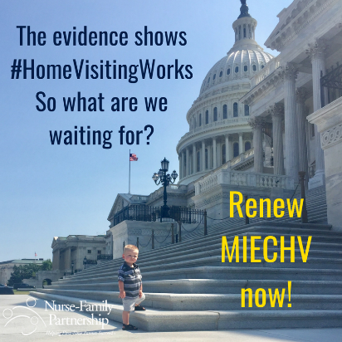
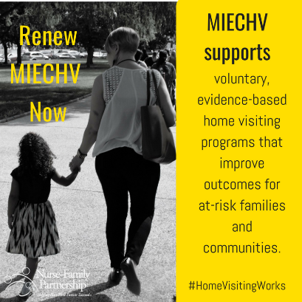
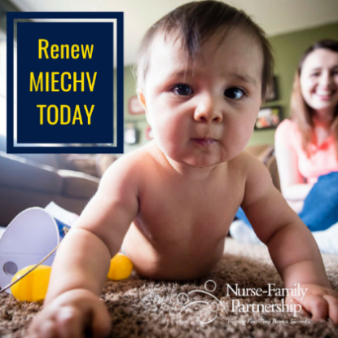
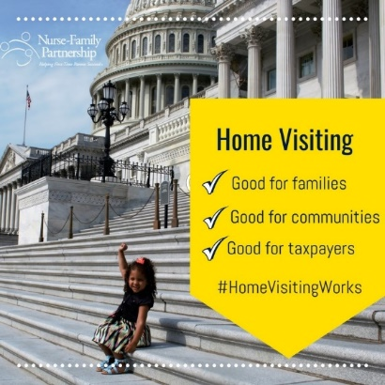
New year, new $$. @memberofcongress #RenewMIECHV for $400 mil. annually for 5 years now.
Email your Members of Congress

Click here to send a direct message to your Members of Congress: https://www.votervoice.net/NFP/campaigns/54522/respond
You can copy and paste the below sample text into the body of the message. If you are a parent, we encourage you to add details about your personal story and the impact home visiting has had on your family.
When emailing your senators:
Subject line: Welcome back to DC – it’s time to Renew MEICHV
Dear Senator/Representative______,
My name is ______ and I live in _______.
I’m writing to urge you to include federal funding for home visiting in any funding package passed. MIECHV must be reauthorized for no less than its current funding level of $400 million annually for five years and without a harmful state match.
Congressional inaction let federal funding for home visiting expire more than 100 days ago. We are hearing that some states may soon freeze enrollment, putting home visiting services at risk. Words of support for the program are not enough – we need action. Reauthorize federal funding for home visiting now.
The clock is ticking. Every second longer that Congress waits is a second closer to lost services and lost jobs.
Thank you.
Sincerely,
NAME
CITY

